Raritan Valley Wrestling League, LLC.
24 King George Road
Warren, NJ 07059
www.rvwrestlingleague.com

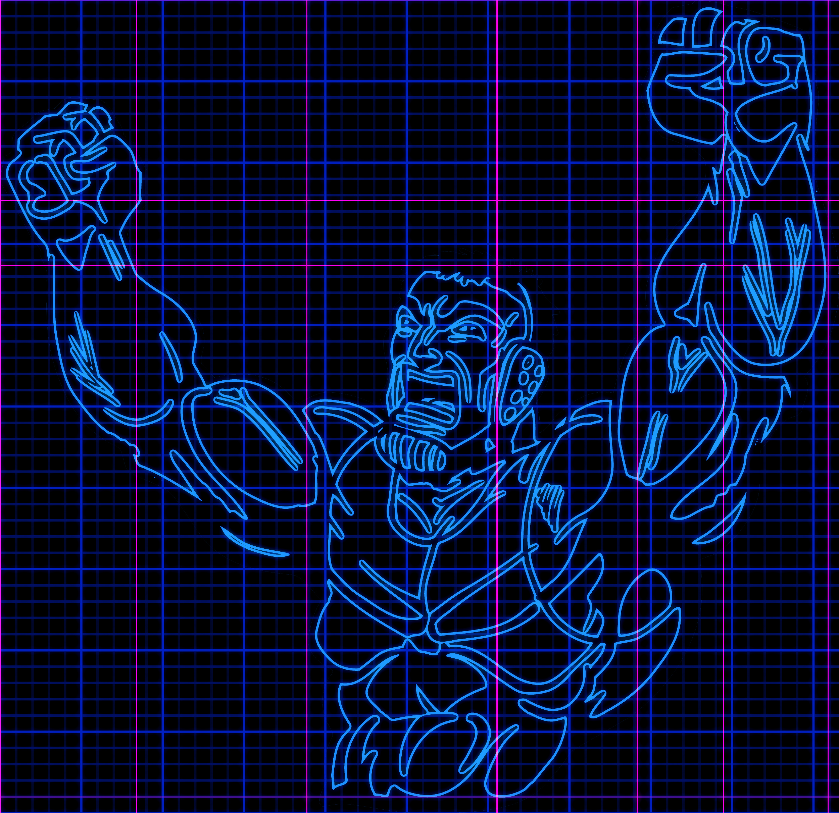

Welcome to the 2017-2018 Raritan Valley Wrestling League. This league was founded on the premise of development and is a stepping-stone to the more competitive wrestling leagues and competition in New Jersey.

Our goal at Raritan Valley Wrestling League is to develop well-rounded young wrestlers who learn not only the fundamentals of the sport, but also the importance of what it means to be a wrestler. Wrestling embraces and teaches an array of life lessons (self-confidence, mental toughness, discipline, physical fitness, competiveness, self-defense, and sportsmanship) that will undoubtedly improve an athlete’s capabilities in other sports, as well as life in general.

The 2017-2018 wrestling season promises to be a good one. With a total of 8 teams, we will be organizing 5 King of the Mat tournaments (directed to the newer wrestler - 3yrs or less experience), 7 league matches, and 2 League tournaments (highlighting some of RVWL's best).

As many of you know, we are a non-profit league and will use the funds to pay for the clerical items, referees, tournament fees, trophies, and t-shirts. All teams must provide a Certificate of Liability Insurance prior to the beginning of the season. Please submit payment and the certificates of liability insurance to the following address:
RVWL - 24 King George Road, Warren, NJ 07059.

Registration Fee for FULL MEMBERS: $725.00
All registration fees and liability certificates are due by Wednesday, November 1st.
Our tax id# is 46-4143913

Thank you again for choosing Raritan Valley Wrestling League. Best of luck to your team and all of our wrestlers in the 2017-18 season...and God bless!

Mark Claxton
President
Raritan Valley Wrestling League

Raritan Valley Wrestling League Board of Directors
President – Mark Claxton
Vice President - Frank Northup
Treasurer - Pat Balesteri
Recording Secretary - Joseph Marchese
Trustee - Alan Klein

